Report

1.Can you tell me no. of vehicles by brand available on e-bay for sale with the help of visualization.

Here is the visualization of the number of vehicles by brand available on e-bay.

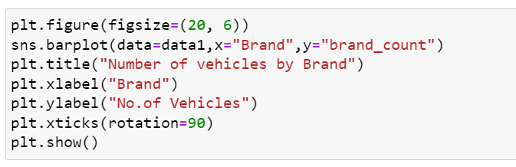

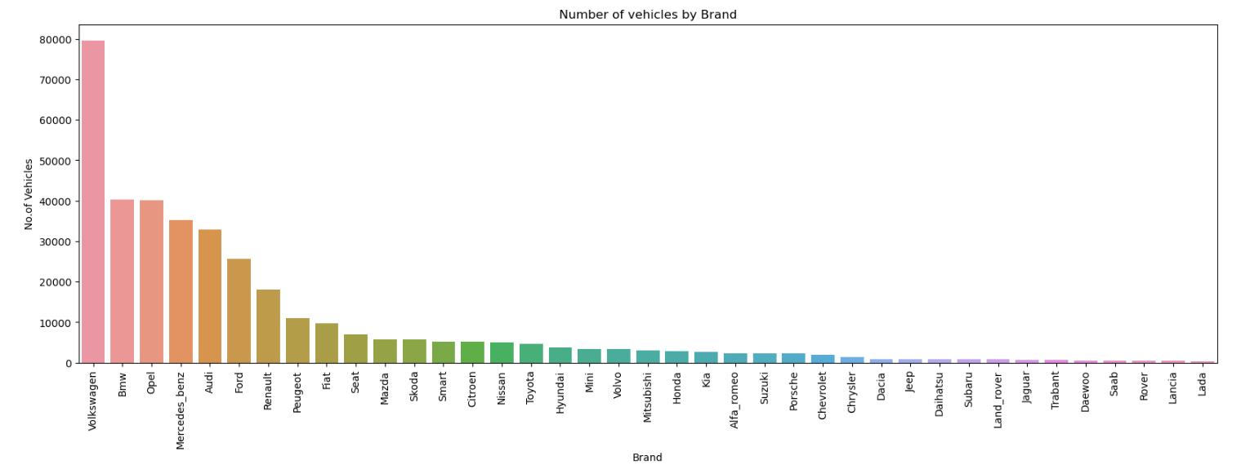

***2.What is the average price for vehicles based on the type of vehicle as well as on the type of gearbox. Explain me with both numerical and visualization analysis.***

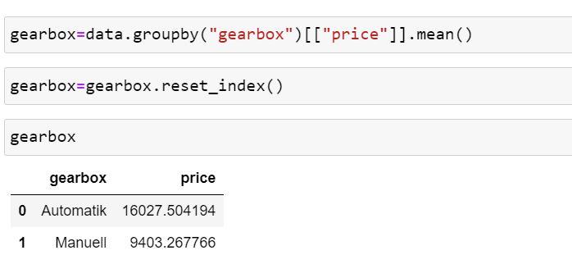

***Here is the average price for vehicles based on the type of vehicle as well as on the type of gearbox with both numerical and visualization analysis.***

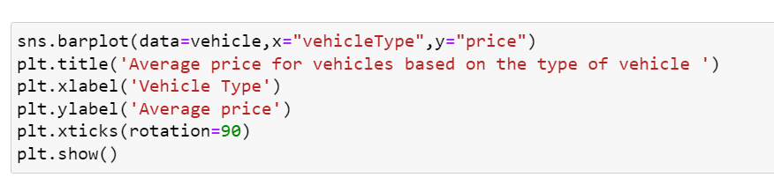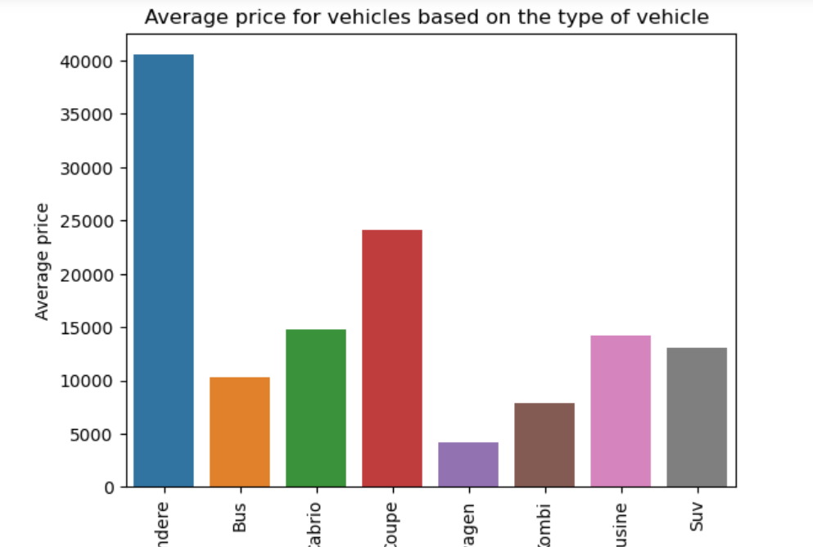

Andere Bus Cabrio Coupe Klein-wagon Kombi

Limousine Suv

